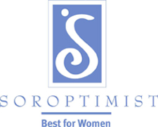
Community Service Funds Application

Soroptimist is a global volunteer organization that provides women and girls with access to the education and training they need to achieve economic empowerment.

Deadlines are November 15 and March 15

Applicant Information
Name of Applicant/Group
Contact Person
Address:
Telephone Email
Indicate any of the following which describe the applicant and the geographic area it serves:

□ For Profit
□ Nonprofit (501(c)(3))
□ State/Local Govt.
□ Local
□National
□ International

Description: In the space below briefly state the project (attach a separate page if more room is needed) .

Is the project new or continuing? □ New □Continuing
Funds needed by:

Amount requested:

Are there additional funds from other sources? Please list the sources and amounts below:

Budget Worksheet: Each budget Item must be fully identified and each item listed separately. See the example
Item Description | Number of Items | Cost Each | Total Cost
2 pocket paper folder with prongs | 10 | .15 | 1.50

Total Cost of All Items/Total Amount Requested __________________

Statement by Applicant: By signing or typing your name below, you (the applicant) affirm that the information in this application is complete and accurate; agree to provide additional information and photographs if requested; and agree to provide a final report or present a program on the use of funds received.

Applicant:

Date:

Send completed form to Community Service Committee, Soroptimist International of Laramie, P.O. Box 1372 Laramie, WY 82073-1372 or silaramie@soroptimist.net by November 15 or March 15.

